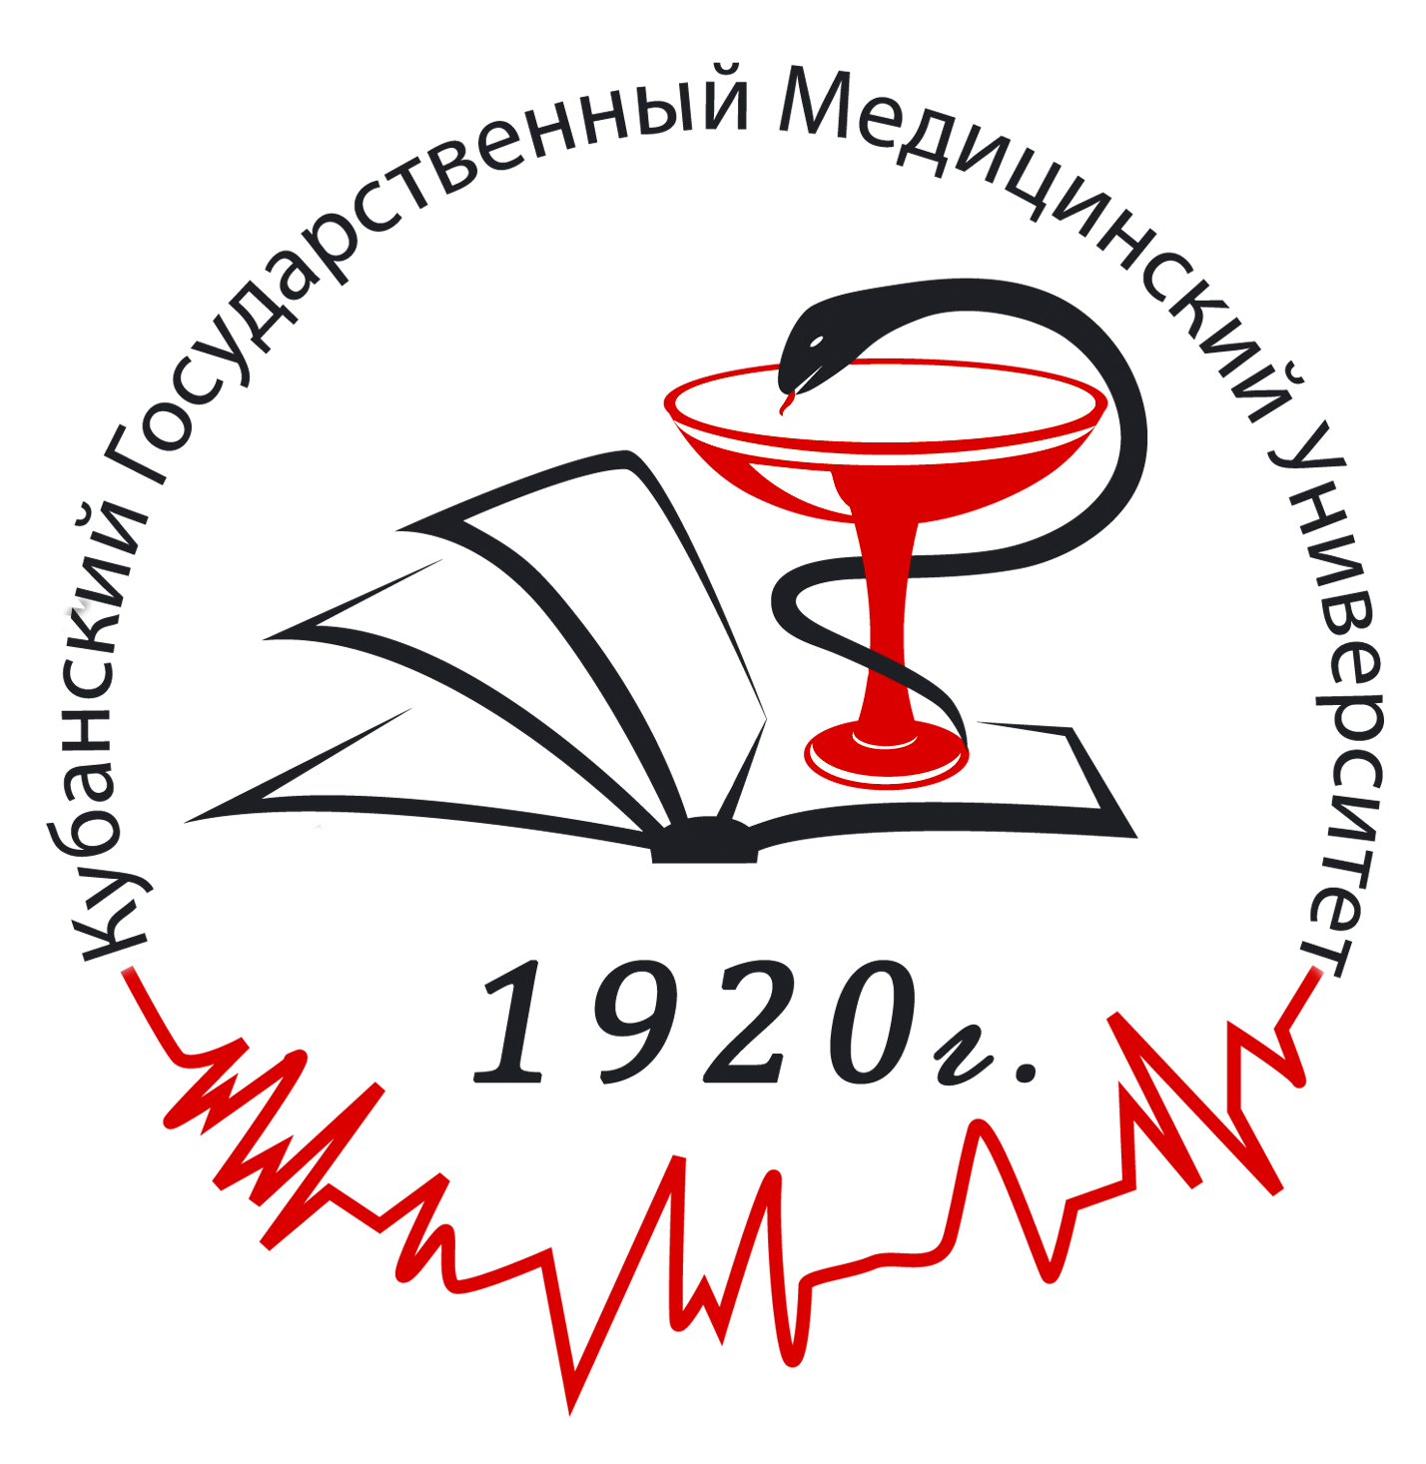
State Budget Educational Institution of Higher Education
«Kuban State Medical University»
Of the Ministry of Healthcare of the Russian Federation
(SBEI HE KSMU of the Ministry of Healthcare of the Russian Federation)

350063, Krasnodar, Sedina str., 4
Phone number +7(861)268-55-51
e-mai: mno.ksma_1921@mail.ru
web-site: http://www.ksma.ru

SBEU HE KSMU of the Ministry of Healthcare of the Russian Federation accepts foreign citizens only on a contractual basis. The educational process at the preparatory department starts in October 1.

It is necessary to attach the copy of your passport and educational documents translated in Russian.

The form for foreign citizens who is enrolling at the preparatory department SBEU of the Ministry of Healthcare of the Russian Federation.

Please, insert your last photo here

1. Surname
2. Name (names)
3. Patronymic (if presents)
4. Date of birth |  |  |  |  |  |  | 5. Place of birth |  |  |  |  |  | 6. Gender: М |  | F
 |  |  | (dd/mm/yyyy) |  |  |  |  |  |  | (country, city)
7. Citizenship
8. Passport |  |  |  |  | № |  |  |  | Date of  issue |  |  | Date of expiry
 |  |  |  |  |  |  |  |  |  |  | (dd/mm/yyyy) |  | (dd/mm/yyyy)
9.Marital Status : (mark necessary)
Single Married Divorced Widowed
10.Occupation

11.Home address at the motherland:
(country)
(city)
(region)
(street, home №, flat №)
(post code)
12. Contact Details:
(phone number)
(e-mail address)

13. Education
(List in the chronicle order all schools and universities where you had studied)
Name of School or University | Location (city, country) | Period of education | Educational document

14. Profiency in Russian (mark necessary)
- don’t know;
- know: writing (very good, good, wake)
reading (very good, good, wake)
speaking (very good, good, wake)

15. You choose preparatory department as: (mark necessary)
- the opportunity to study Russian;
- the education basis for future enrolment at the medical university .

16. What field of study are you planning to choose for your education after preparatory department?
- General Medicine
- Stomatology
- Pharmacy

17. Accommodation
- dormitory;
- do not need.

18. The place of visa’s issue:
city
country*

- For obtaining the visa in third countries it is necessary to present copies of documents which allows to be at the territory of another state (visa, residence permit) with translation in Russian

